ABSTRACT SUBMISSION

March 4, 2024
Deadline for abstract submission for oral presentations

April 1, 2024
Deadline for abstract submission for poster presentations

Abstracts may include: tables, schemes, figures, and references.

To maintain a consistent appearance, all abstracts must be prepared in the following style (see also the template on the next page):
- Maximum space limit is one page.
- Maximum usable area is 17.0 cm wide and 25.0 cm hight.
- Times new roman font (symbol font for special characters).
- 14 point boldface font for the title.
- 12 point underlined font for presenting author (12 point normal font for other authors, if any).
- 12 point italic font for affiliations.
- Affiliations distinguished by superscript numbers if necessary.
- One blank line left between address and the beginning of the abstract
- One blank line left between the end of the abstract and references/acknowledgment (if present).

Proposed session (select one):

[ ] Molecular composition of Food: FoodOmics, Food Chemistry, qNMR, authenticity.
[ ] Food Processing: extrusion, digestion, mild processing, plant-based foods.
[ ] Next NMR developments for Foods: miniaturisation, on/at-line measurements, low/mid field, image/signal analysis.
[ ] Multiscale structure of Food: food physics, water state, structural anisotropy.

Presentation preference*:
[ ] Oral
[ ] Poster

*Select the option oral or poster to indicate that you would like your abstract to be considered for an oral or poster presentation. However, all oral presentation also should be present in the poster session.

IMPORTANT – One person can submit up to two poster or oral presentation.

The posters will be printed by the meeting organizers on white glossy-coated paper, eliminating the inconvenient during the trip. So, all you need to do is to prepare the poster to dimensions of 100 cm width per 120 cm height, save it as a PDF file and then upload it to the meeting webpage (mrfood2024@gmail.com) with subject – poster and send us until May 5th.

Although the organizers will take care of printing, you also have the option to print your own poster and bring it to the meeting if you prefer.

To enhance accessibility, we recommend incorporating a QR code on the poster that links to additional information (e.g., your research group's webpage). This can provide attendees with a convenient way to access supplementary details about your work.
NMR as an analytical monitoring tool for reusing waste citrus to redesign functional foods

*Maria Gabriela A. Carosio¹, Maria C. B. Di Medeiros Leal¹, Paula S. Penteado¹, Mateus L. Segatto¹, Vania Zuin¹, Maria Fátima G. F. da Silva¹ Antonio Gilberto Ferreira¹

¹ Federal University of São Carlos, São Carlos, SP, Brazil
*gabi_carosio@hotmail.com

The food loss that occurs along the food chain can be minimized by exploiting waste and producing value-added products. Important nutritional and health-safe compounds, such as hesperidin abundant in citrus peels¹, are found in inedible parts of citrus fruits, which are eventually discarded or processed into feed. The potential bioactivity of this flavonoid has become a target for the development of its efficient and eco-friendly extraction process and functional food products containing it. The aim of this work was to optimize microwave extraction of hesperidin from industrial citrus peel waste (MAE) and screening and quantification of the compounds by qNMR and UPLC assays. The optimum conditions for maximum hesperidin extraction yield were obtained through factorial statistical analysis 2³, investigating the effects of the variables (isotherm time, and temperature)². For qNMR analysis, the dried solid obtained was weighted in analytical conditions, and spectra were recorded on a 9.4T (400 MHz for ¹H) Bruker Avance III equipped with a BBI probe head using 90º pulse = 12.0 µs, relaxation delay (d1= 25.0 s), acquisition time (AQ= 4.1 s), spectral width (SW= 18 ppm) and a number of scans (ns= 8), according to the workflow below mentioned (Figure 1).
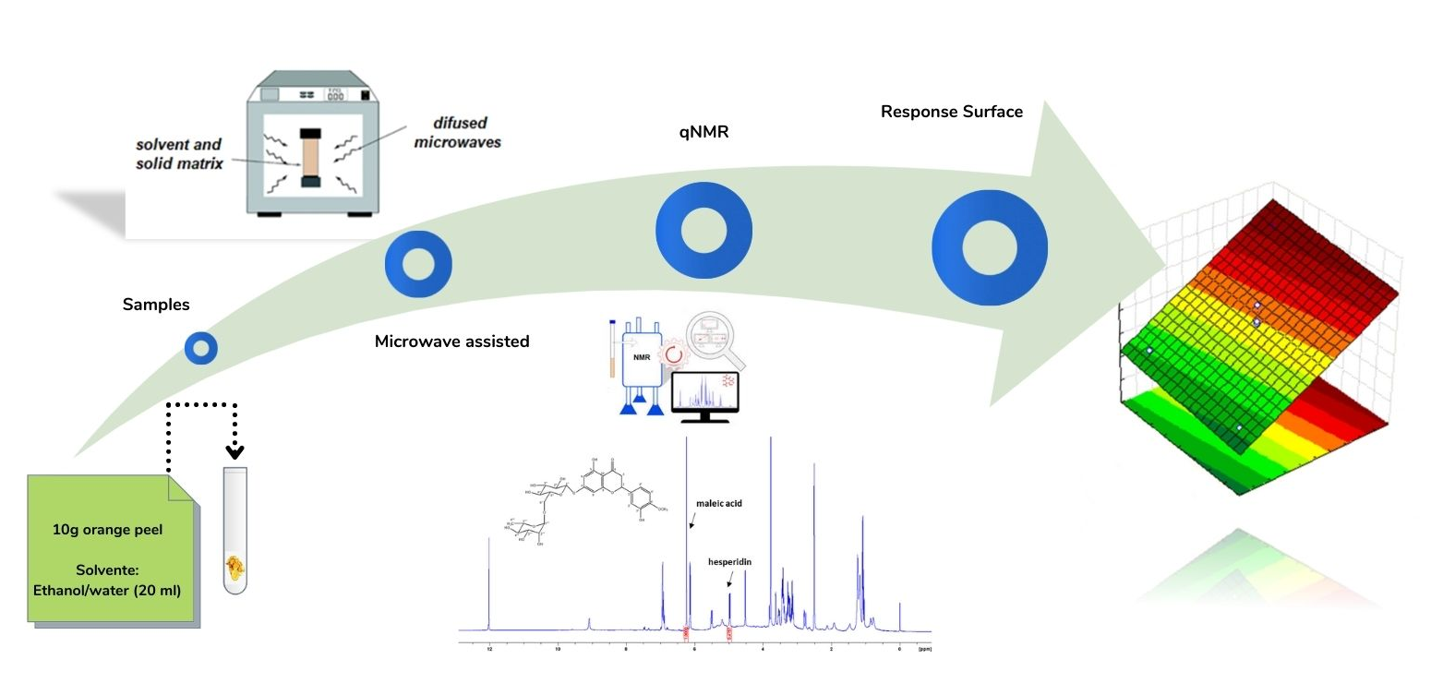
Figure 1. Workflow of the work.

The qNMR results showed that the simple green extraction process using ethanol and microwave at 80 °C recovered hesperidin with (92.4%) purity grade, and similar results were obtained by UPLC (92.3%). These preliminary results indicate that this type of industrial waste should be considered as a potential nutraceutical resource capable of providing effective and low-cost nutritious food supplements. This is mainly due to the low cost and easy availability of fruit residues that would otherwise be discarded as waste in the environment. In addition, the extractive proposal utilized in this work proved to be efficient along with qNMR measurements, requiring less solvent time and simple sample preparation, contributing to an even greener process.

Acknowledgments: CAPES, FINEP, CNPq and FAPESP for financial support.

References
- Shafiya Rafiq; et al. Journal of the Saudi S. of Agricultural Sciences, 17 351-358, (2018).
- Vânia G. Zuin; et al. Pure Appl. Chem. 2020. Conference paper.

