PANEL TITLE – CAPITAL LETTER, FONT LETTER: CALIBRI 14, BOLD FONT, CENTRALIZED BLOCK, SINGLE LINE SPACING (Title in Portuguese or in writing work language. Where appropriate, insert footnote with funding)

ENGLISH TITLE – CAPITAL letter, ITALIC FONT, WITH OUT BOLD FONT, CENTRALIZED BLOCK, SINGLE LINE SPACING, FONT LETTER: CALIBRI 10 (or in Portuguese, in works written in another language cases)

TITLE IN SPANISH – CAPITAL letter, ITALIC FONT, WITH OUT BOLD FONT, CENTRALIZED BLOCK, SINGLE LINE SPACING, FONT LETTER: CALIBRI 10 (by international event character, author must ensure that title and abstract text are always in Portuguese, English and Spanish. If it were consistent form, Spanish language can be replaced by French language.

- Proponent A (Institution – e-mail) – authored in Calibri 10, left-aligned, name in bold font
- Proponent B (Institution – e-mail) – coordinator name should be underlined. Each thematic panel proposal shall contain only one (1) coordinator
- Proponent C (Institution – e-mail) – put institution name and e-mail in parentheses, as it`s shown
- Polemicist debater (Institution - e-mail) - name of polemicist debater must come in bold and italic font, with indentation. It`s reiterated that debater cannot be any one of proponents, and his registration in event is recommended, but optional. Will get a polemicist debater certificate.

- Thematic subaxis: Identify here the axis/subaxis with which thematic panel belongs, in accord as described on event website.

Abstract:
Abstract should be a single paragraph, contain from 800 to 1,200 characters (approximately 170 to 220 words or 10 to 15 lines), Calibri font size 10 - simple space, justified, in italics. 1.0 cm indentations on each side. The text of abstract should represent of all the work content, contemplating the panel proposal, justification and other elements considered necessary according for proponents.
Palavras-chave: 3 to 5 keywords.

Resumo:
O resumo (abstract in English) precisa ser coerente com a versão em inglês (Abstract). O texto deve ser formatado com os mesmos padrões especificados anteriormente para o resumo em inglês.
Palavras-chave: 3 a 5 palavras-chave.

Resumen:
El resumen (resumen en espanhol) debe ser consistente con la versión portuguesa (Resumo). El texto debe estar formateado con los mismos estándares enumerados anteriormente para el resumen en inlgés.
Palabras clave: de tres a cinco palabras clave.

1. Subtitles sections must be in Calibri 14, bold font and only in initial place of sentence in capital letters. All titles must be numbered sequentially

Thematic panels proposals should have from five (5) to eight (8) pages, including abstract and bibliographic references. Texts must be sent for evaluation, in DOC or DOCX format. All work must strictly follow of this model standards.
Panelists names and polemicist debater MUST are indicated at the same submission time, since ad hoc committee will evaluate both the proposal content and the curriculum proponents.
All text paragraphs must follow the next formatting standard (similar to this paragraph itself): Calibri 12 font, simple spacing between lines, justified block, with the first line of 1.25 cm indentation. There should be no spacing before or after paragraphs or between titles and subtitles.
Before each section subtitle must have two (2) "enter" and after subtitle must have one (1) "enter". In second-level subtitles cases, only one (1) "enter" should be inserted before and another after referred subtitle. Between paragraphs, there should be no spacing ("enter") or automatic spacings. In nowhere the work should automatically styles of text editors be applied.

1.1. Level 2 subtitles shall be justified, in calibri 12 font, bold, italics and only one the initial in capitalic sentence (such as this title here)

In relation with pictures or figures, it should have a good resolution, be numbered sequentially and must have title as in the example below (Figure 1). Figures title must be representative and formatted without bold letter, in font Calibri 12, as in Figure 1. Title and image should be centered. Figures and tables should be cited in text and inserted as close place as possible for passage to which they refer, in according ABNT standards. All figures must be accompanied by source in every case (as in example below), also centralized.

Figure 1 – Image and title must be centered, title being in Calibri 12.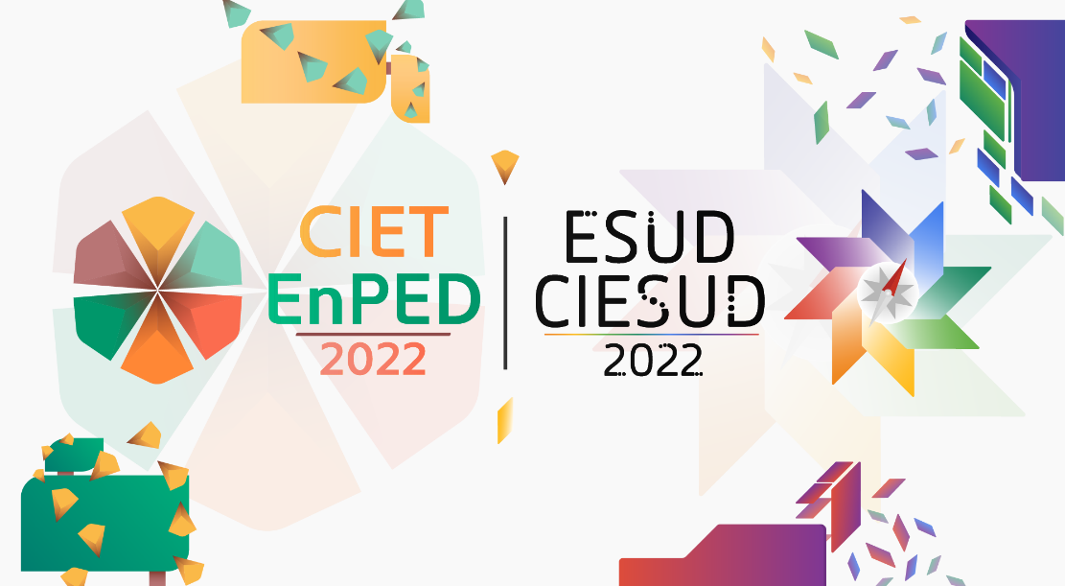
Source: The source image should be indicated, even if it’s authorship itself, in Calibri 12.

Before image should be given a space ("enter") and, after information about figure source, there should also be a space ("enter"), as in above example. Tables follow the same orientation with figures.

Table 1 – The table titles comes before it`s insertion, with table and title centered in Calibri 12.
A | B | C
1 | 2 | 3
1 | 2 | 3
1 | 2 | 3
Source: Own Authorship (or indicate the table source, in Calibri 12, as well as figures).

Frame 1 – The title of frames comes before their insertion, frame and title are centered, in Calibri 12.
A | B | C | D
Text | Text | Text | Text
Text | Text | Text | Text
Source: Own Authorship (or indicate the table source, in Calibri 12, as well as figures).

1.2. Quotations in the body text and in the references list

Citations in the body text and in the bibliographic references list must there are fulfill with ABNT standard. Bibliographies list used in the work should come at the end of the work and not in footer. Body text citation could be direct or indirect, and there should be a page indication of the quoted segment, when it`s direct citation

2. Structure of panel proposals

Proposals for thematic panels should summarize general theme to be addressed by proposer teams. It`s suggested that they contain at least the following topics: introduction; general proposers presentation and topic to be discussed; justification about relevance of discussion with due theoretical-scientific basis and final considerations. Other elements may be included, provided that page limit and other guidelines are respected.

2.1. Panel presentation

Thematic panels will be indicated for their presentation in roundtable format. Panels will be presented in synchronously mode and, at the authors discretion, may be presented in virtual and/or face-to-face steps.

- About thematic panels: what are they?

CIET:EnPET|CIESUD:ESUD|2022 thematic panels are proposals organized as a round table, addressing related themes for event axes and subaxes, in a proponents reflection wheel. Each proposal must involve at least researchers from two (2) different institutions (national and/or foreign) from at least two (2) different geographical regions of Brazil (note that this requirement refers to geopolitical regions and not distinct states). In addition, each proposal can have up to eight (8) proposers, from two or more Brazilian or foreign institutions, and may be submitted in Portuguese, English or Spanish language. It`s important to highlight that each event participant could submit (or be among between proponents) no more of two (2) thematic panels submitted for evaluation. Among proponents of a thematic panel, at least one (1), coordinator preferentially, should be a doctorate researcher.
Each panel should contain, among proposal participating in the discussion, one (1) coordinator (who should be one of proponents). In addition by proponents, panelists shall appoint one (1) polemicist debater (who should not be one of proponents).
Every panel will be synchronous (virtual and/or face-to-face) and will last approximately one hundred and five minutes (1h45min) divided as follows: 15 minutes for panel and participants presentation by debater part; up to 60 minutes maximum for themes presentation by each participant; at least 30 minutes for discussion among participants with possible opening questions to listeners. Debater mediate the whole process.
Any proposal should have relevant content and consistent with general event theme and its axes/sub-axes and will be analyzed by ad hoc reviewers indicated by event organization. In the panels proposal, be should consider the theoretical-scientific consistency, even if they are reflections configured as an experience report and/or theoretical essay.
Presentation of panel (not submission and approval term) is conditional upon registration confirm and payment of at least three (3) proponents (not debater including, their registration is optional).
After completion of thematic panel, participants will be able to develop a theoretical essay based on inside discussion. Detailed information about this kind of essays is present on event website, in the tab "jobs and panels".

- About other working formats

On CIET:EnPET|CIESUD:ESUD|2022 there is also space for papers submission in Full Papers or Extended Abstracts format. There are information and specific templates for these work formats. All important information, as well templates, is available on the CIET:EnPET|CIESUD:ESUD|2022 website, with name "Works and Panels" in tab. It’s reiterated that this model concerns only proposals for thematic panels.

3. References

List of references (bibliographic and similar cases) should strictly follow ABNT standards (NBR 6023:2018, with 2020 errata). It should be included in the references list, only that were effectively mentioned in text corpus. Examples:

- Complete book:

LISPECTOR, C. Living water. 11. ed. Rio de Janeiro: Francisco Alves, 1990.

- Article, section and/or matter of periodic publication in electronic médium:

SANTOS, H. M. DOS; FLORES, D. The digital archival document as a research source. ​Perspectives in Information Science, Belo Horizonte, v. 21, n. 4, p. 121-137, Oct./Dec. 2016. Available in: http://www.scielo.br/scielo.php?script=sci_arttext&pid=S1413-99362016000400121&lng=pt& nrm=iso&tlng=pt. Accessed: 25 Apr. 2017.

- Monograph in electronic medium:

CAVALCANTI, F. S. Teaching musical rhythm: analyzing a successful pedagogical practice. 2004. 146 p. Dissertation (Master in Education) – Center for Education and Human Sciences, Federal University of São Carlos, 2005. Available in: https://repositorio.ufscar.br/bitstream/handle/ufscar/2685/516.pdf?sequence=1&isAllowed=y. Accessed: 12 May 2017.

Work developed with financial support from XX (if there is no funding, remove this footnote)
More examples can be found at ABNT original document: https://drive.google.com/file/d/10gdsn_YgF0Qdckcs0hQfeb3lqfrkdmka/view?usp=sharing

