PAPER TITLE – CAPITAL LETTER, FONT LETTER: CALIBRI 14, BOLD FONT, CENTRALIZED BLOCK, SINGLE LINE SPACING (Title in Portuguese or in writing work language. Where appropriate, insert footnote with funding)

ENGLISH TITLE – CAPITAL letter, ITALIC FONT, WITH OUT BOLD FONT, CENTRALIZED BLOCK, SINGLE LINE SPACING, FONT LETTER: CALIBRI 10 (or in Portuguese, in works written in another language cases)

TITLE IN SPANISH – CAPITAL letter, ITALIC FONT, WITH OUT BOLD FONT, CENTRALIZED BLOCK, SINGLE LINE SPACING, FONT LETTER: CALIBRI 10 (by international event character, author must ensure that title and abstract text are always in Portuguese, English and Spanish. If it were consistent form, Spanish language can be replaced by French language.

- Author A (Institution – e-mail) – authored in Calibri 10, left-aligned, name in bold font
- Author B (Institution – e-mail) – Author’s name should be underlined
- Author C (Institution – e-mail) – put institution name and e-mail in parentheses, as it`s shown

- Thematic subaxis: Identify here the axis/subaxis with which paper work belongs, in accord as described on event website.

Abstract:
Abstract should be a single paragraph, contain from 800 to 1,200 characters (approximately 170 to 220 words or 10 to 15 lines), Calibri font size 10 - simple space, justified, in italics. 1.0 cm indentations on each side. The abstract text should represent of all work content, contemplating the paper proposal, objectives, methodologic process, essential/theoretical discussion and main results.
Palavras-chave: 3 to 5 keywords.

Resumo:
O resumo (abstract in English) precisa ser coerente com a versão em inglês (Abstract). O texto deve ser formatado com os mesmos padrões especificados anteriormente para o resumo em inglês.
Palavras-chave: 3 a 5 palavras-chave.

Resumen:
El resumen (resumen en espanhol) debe ser consistente con la versión portuguesa (Resumo). El texto debe estar formateado con los mismos estándares enumerados anteriormente para el resumen en inlgés.
Palabras clave: de tres a cinco palabras clave.

1. Subtitles sections must be in Calibri 14, bold font and only in initial place of sentence in capital letters. All titles must be numbered sequentially

Works into extended abstract format should have from three (3) to five (5) pages, including abstract and bibliographic references. Texts must be sent for evaluation, in DOC or DOCX format. All work must strictly follow of this model standards.
At time of works submission, principal information referring with authors, including their names, must be omitted. It’s also essential to replace names or other personal/institutional information with symbols such as “***” to avoid authors identification.
All text paragraphs must follow the next formatting standard (similar to this paragraph itself): Calibri 12 font, simple spacing between lines, justified block, with the first line of 1.25 cm indentation. There should be no spacing before or after paragraphs or between titles and subtitles.
Before each section subtitle must have two (2) "enter" and after subtitle must have one (1) "enter". In second-level subtitles cases, only one (1) "enter" should be inserted before and another after referred subtitle. Between paragraphs, there should be no spacing ("enter") or automatic spacings. In nowhere the work should automatically styles of text editors be applied.

1.1. Level 2 subtitles shall be justified, in calibri 12 font, bold, italics and only one the initial in capitalic sentence (such as this title here)

In relation with pictures or figures, it should have a good resolution, be numbered sequentially and must have title as in the example below (Figure 1). Figures title must be representative and formatted without bold letter, in font Calibri 12, as in Figure 1. Title and image should be centered. Figures and tables should be cited in text and inserted as close place as possible for passage to which they refer, in according ABNT standards. All figures must be accompanied by source in every case (as in example below), also centralized.

Figure 1 – Image and title must be centered, title being in Calibri 12.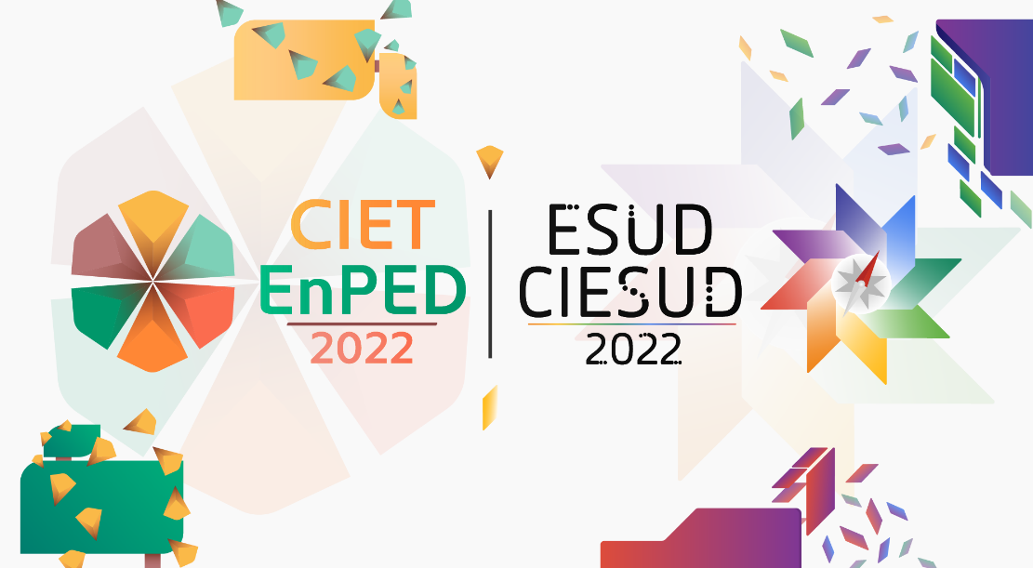
Source: The source image should be indicated, even if it’s authorship itself, in Calibri 12.

Before image should be given a space ("enter") and, after information about figure source, there should also be a space ("enter"), as in above example. Tables follow the same orientation with figures.

Table 1 – The table titles comes before it`s insertion, with table and title centered in Calibri 12.
A | B | C
1 | 2 | 3
1 | 2 | 3
1 | 2 | 3
Source: Own Authorship (or indicate the table source, in Calibri 12, as well as figures).

Frame 1 – The title of frames comes before their insertion, frame and title are centered, in Calibri 12.
A | B | C | D
Text | Text | Text | Text
Text | Text | Text | Text
Source: Own Authorship (or indicate the table source, in Calibri 12, as well as figures).

1.2. Quotations in the body text and in the references list

Citations in the body text and in the bibliographic references list must there are fulfill with ABNT standard. Bibliographies list used in the work should come at the end of the work and not in footer. Body text citation could be direct or indirect, and there should be a page indication of the quoted segment, when it`s direct citation

2. Structure of extended abstracts

Extended abstracts must include typical scientific paper sections, such as introduction, theoretical perspective, methodological perspective, results and discussion, final considerations (conclusions) and texts list implemented into references.

2.1. Work presentation

Approved extended abstracts will be indicated for their presentation in oral communication format. The works will be presented at the author(s) discretion and may be presented in virtual an/or face-to-face stages

- About extended abstracts: what are they?

CIET:EnPET|CIESUD:ESUD|2022 extended abstracts are normally texts resulting from scientific research in progress or reports for academic or pedagogical experiences, with consistent perspective to theme and axis/sub-axis into event, in addition because respect technical guidelines for organization and text format. Each extended abstract can have up to eight (8) authors, and may be submitted in Portuguese, English or Spanish language, always omitting authorship information at time work submission, it for guarantee undercover and anonymous stage between authors and reviewers.
It’s important to note that each participant may be author of up two (2) extended abstracts for evaluation. There is no limit by co-authored works. Work presentation (not submission or evaluation) as well as its inclusion on event`s memory, is conditioned with confirmed registration payment of at least three (3) authors/co-authors registered in event, OR, otherwise, one (1) author registered on the event and at least two (2) co-authors with duly paid co-authorship value. It’s important to notate that payment of co-authorship value, does not give rights for event participation (or for obtain equivalent certificate).

- About other working formats

On CIET:EnPET|CIESUD:ESUD|2022 there is also space for papers submission in Thematic Panels or Full Papers format. There are information and specific templates for these work formats. All important information, as well templates, is available on the CIET:EnPET|CIESUD:ESUD|2022 website, with name "Works and Panels" in tab. It’s reiterated that this model concerns only proposals for extended abstracts.

3. References

List of references (bibliographic and similar cases) should strictly follow ABNT standards (NBR 6023:2018, with 2020 errata). It should be included in the references list, only that were effectively mentioned in text corpus. Examples:

- Complete book:

LISPECTOR, C. Living water. 11. ed. Rio de Janeiro: Francisco Alves, 1990.

- Article, section and/or matter of periodic publication in electronic médium:

SANTOS, H. M. DOS; FLORES, D. The digital archival document as a research source. ​Perspectives in Information Science, Belo Horizonte, v. 21, n. 4, p. 121-137, Oct./Dec. 2016. Available in: http://www.scielo.br/scielo.php?script=sci_arttext&pid=S1413-99362016000400121&lng=pt& nrm=iso&tlng=pt. Accessed: 25 Apr. 2017.

- Monograph in electronic medium:

CAVALCANTI, F. S. Teaching musical rhythm: analyzing a successful pedagogical practice. 2004. 146 p. Dissertation (Master in Education) – Center for Education and Human Sciences, Federal University of São Carlos, 2005. Available in: https://repositorio.ufscar.br/bitstream/handle/ufscar/2685/516.pdf?sequence=1&isAllowed=y. Accessed: 12 May 2017.

Work developed with financial support from XX (if there is no funding, remove this footnote)
More examples can be found at ABNT original document: https://drive.google.com/file/d/10gdsn_YgF0Qdckcs0hQfeb3lqfrkdmka/view?usp=sharing

