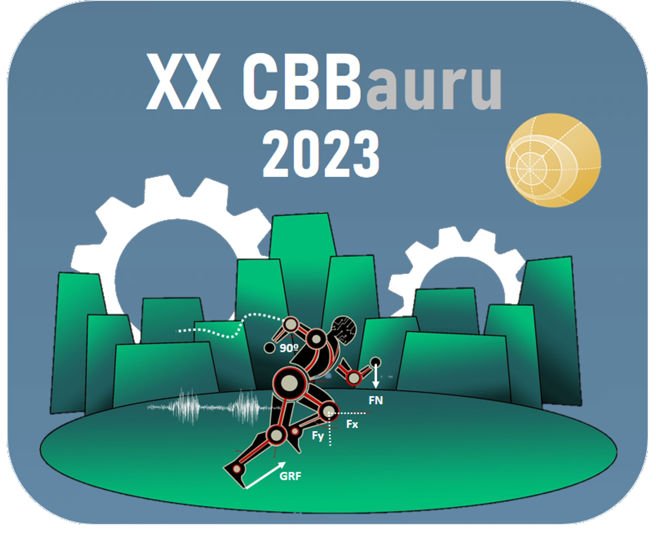
Vol 17 – Supplement  Apr. 2023  Brazilian Journal of Motor Behavior  ISSN 2446-4902


Insert your abstract here. Use ‘’Calibri’’ font, size 8.
First Authors’ Name
University, Department, Laboratory (abbreviation/short name)
Third Authors’ Name
University, Department, Laboratory (abbreviation/short name)

Second Authors’ Name
University, Department, Laboratory (abbreviation/short name)

Title of the work presentation:
Formatting model

Abstract should contain between 250 and 500 words. Two (2) references and one (1) table or figure can be included. Do not highlight the text of any kind. The abstract is structured as follows: contextualization, objectives, material and methods, results, conclusions and bibliographic references. The references are not considered for word counting. Avoid abbreviations whenever is possible.
Fourth Authors’ Name
University, Department, Laboratory (abbreviation/short name)

Fifth Authors’ Name
University, Department, Laboratory (abbreviation/short name)

Up to six (6) participants per abstract are allowed, including the author, the co-authors and the advisor.
Contextualization:
Sixth Authors’ Name
University, Department, Laboratory (abbreviation/short name)

Objetives:
Material and methods:
Results:
Conclusions:
Bibliographic references:
XX Congresso Brasileiro de Biomecânica
Bauru - SP

