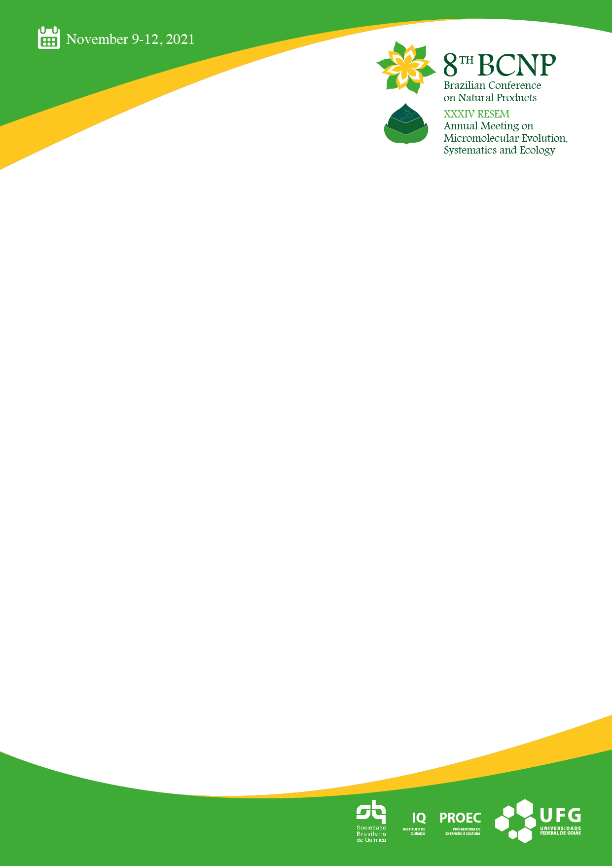

**Title in Arial 12 point – Upper and Lower Case**

Presenting author, Co-Authors

*Affiliation*

*Addres*s

*e-mail address*

These instructions are an example of what a properly prepared meeting abstract should look like. Proper column and margin measurements are indicated.

The abstract **should not exceed** **ONE PAGE** of text, references, tables and figures. Abstracts exceeding this limit may be cut without consideration of content after the first page.

Type the title single-spaced in 12-point Arial bold, upper and lower case and NOT in ALL CAPITAL letters.

Type the author(s) name(s) single-spaced in 10-point Arial regular.

Type the affiliation(s) and address(es) single-spaced in 10-point Arial italic.

Type the body of the abstract text (including references and tables) single-spaced in   
10-point Arial regular.